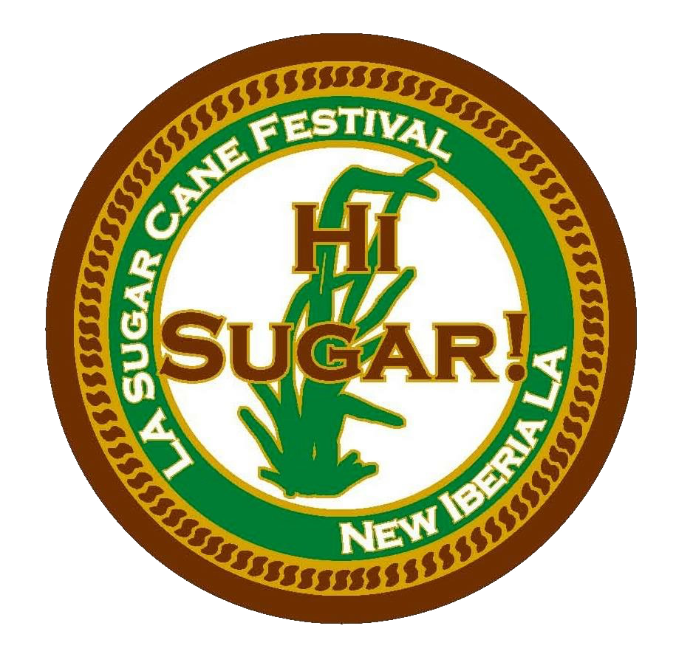

Dear Food Vendor:
Thank you for expressing an interest in being a Food Vendor for the 2023 Sugar Cane Festival which will be held Boulginy Plaza in New Iberia on September 22, 23 & 24, 2023.

PLEASE NOTE: ALL FOOD VENDORS MUST HAVE A FOOD TRUCK/TRAILER
Please find enclosed an application packet to become a vendor. Please fill out the application completely, attach deposit and proof of General Liability Insurance and return to the following address:

LA Sugarcane Festival & Fair Association
Vendor Committee
P.O. Box 9768
New Iberia, LA 70562
The deadline for vendor applications is September 1, 2023. We will let you know if you have been accepted as soon as possible.
If you have any questions please contact us at sugarcanefestivalvendor@gmail.com.

REGISTRATION REQUIREMENTS:
The fee for food vendors is $250.00 per Food Truck. Your Food Truck must have everything you need to operate. Electricity, Water, etc. will NOT be provided.
You are required to keep your area free of debris and to dispose of your cardboard boxes and waste water must be contained in your truck. Waste Water cannot be emptied on the street or the bayou at any time. At the end of the festival, your area will be inspected failure to clean up your area will disqualify you from future festivals.
Deadline for the acceptance of applications is September 1, 2023. Reservations will be confirmed upon decision of Vendor Committee. In order for the committee to consider your application, the following is necessary:
- Completed application form, with pictures of your food truck, and your menu.
- $ 250.00 fee, (Money order or cashier’s check ONLY). You may also use a credit card to pay your fee. There will be an additional service charge of $3.00. Personal checks will not be accepted.
- Copy of General liability insurance (minimum of $250,000). Your insurance policy binder must include the following wording: Insurance Certificate that indemnifies the LA Sugar Cane Festival & Fair Association.
- City of New Iberia Occupational License

You will not be able to set up your booth until your insurance policy is filed in our office.

Copyrighted Items and Contracts Exclusives:
The La Sugar Cane Festival Association has copyrighted the following phrases:
- "Hi Sugar"
- Louisiana Sugar Cane Festival and Fair Association”

No vendor will be allowed to use or sell any items with the above copyrighted phrases printed on them. We will strictly adhere to this policy.

Downtown Festival Activity Dates and Times:
Friday, September 22 5:00 PM until 11:00 PM
Saturday, September 23 9:00 AM until 11:00 PM
Sunday, September 24 9:00 AM until.

SET UP TIMES AND REQUIREMENTS:

Set up begins at 12:00 pm on Friday afternoon of the festival. If you choose to leave you must wait until the New Iberia City Police clear the crowds from the festival area and open the streets. No parking of vehicles, etc. or setting up allowed on Thursday for safety reasons as our LASCFFA Directors are busy setting up their areas until late Thursday evening. Friday is dedicated to setting up vendors. Please do not call or show up on Thursday asking if you may set up.
You are required to have all vehicles off the festival grounds by 3:00 PM on Friday and 8:00 AM on Saturday and Sunday.
You will not be allowed to drive your vehicles back in to load up until 30 minutes after the New Iberia City Police have cleared the crowd from the festival grounds. This policy will be strictly adhered to with NO EXCEPTIONS. These regulations are set to insure the safety of our festival guests.
In the event you are chosen to be a food vendor, you will receive your permit, cite map and Sales Tax forms.
If you are accepted and cancel after September 15th 2023 you will not be refunded.

2023 Louisiana Sugar Cane Festival
Food Vendor Application Form
Bouligny Plaza

Name: __________________________________________________________

Address: ________________________________________________________
City: ___________________________ State: __________ Zip: _____________
Contact Person: _________________________________________________
Phone Number: ____________ Email Address: ______________________

Please list and describe all items you wish to sell: Please note that we are trying not to duplicate food items to be fair to all food vendors so the first application we receive will be given preference.

Name and Description of Food:
________________________________________________________________

________________________________________________________________

________________________________________________________________

REQUIREMENTS: Picture of your food Truck. Truck must operate on generator, have the water tank full and hold gray water. NO releasing waste water on the street or bayou at any time. If you do not comply you will be asked to leave the Festival.

Please charge to my VISA or MASTERCARD Amount: $________________
Fee + 3.00 charge
Name of Card Holder: ____________________________________________

Account Number: _______________________________________________

Exp. Date: __________ CVV: ____ (3 digits on back) Zip code: ____________
I understand that I will be charged on the date of acceptance of my booth application. I understand that in the event that I cannot attend after September 15, 2023 I will not receive a refund.

Signed: ________________________________________
Date: ___________________________________________

